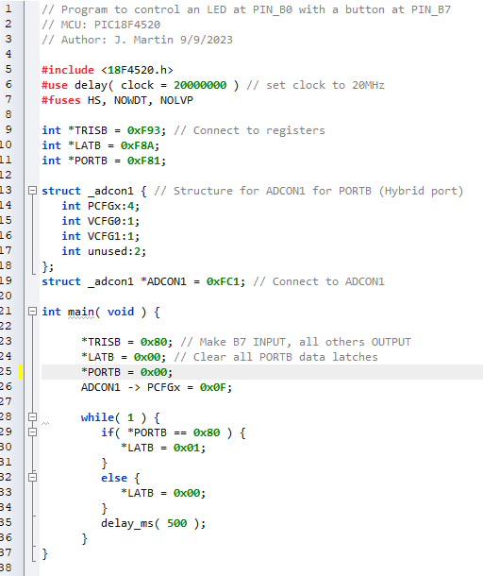

This program produces an odd delay in the LED. However, I’m not sure what’s wrong here. Maybe it’s the simulation and RAM usage on my PC when running the simulation. Although, I have 32GB of RAM and the sim only uses 9%.